**Group Progress Summary**

The goal of the project is to aid in accident prevention through a device that will aid users identify and anticipate obstacles in their vehicle’s blind spot. In addition, the device will be able attain vehicle control to prevent the user from steering into obstacles in the blind spot. In order to achieve this, the group will build a prototype to be tested on scaled down vehicles (i.e. remote controlled cars) under simulated road conditions.

The project is broken down into 3 distinct modules:

1: Obstacle Detection Module

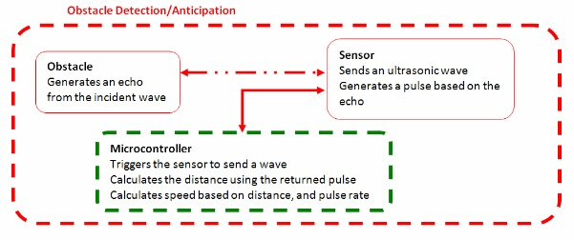

Tanzim Mokammel ( TM ), with the assistance of Valikhan Kuparov (VK) are responsible for this module. The basic functionality of the obstacle detection module is complete. The microcontroller can drive the sensor, and calculate the distance and speed of an object. This functionality has been verified for the situation where the sensor remains stationary. The accuracy of the calculations is slightly below the initially set constraints. The next step is to mount the sensor on a moving obstacle, and complete the detection module. In addition, the “time left” calculations need to be tested. Code for the “time left” calculations are written, but have to be verified once the sensor is mounted on the user vehicle.

2. Output Module

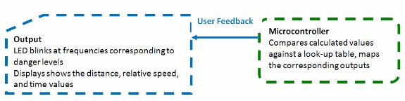

VK, with the assistance of TM is responsible for this module. The LCD display is fully functional, and is able to display the distance, and speed calculations from the microcontroller. It will be able to display the time calculations as soon as it is implemented in the input module. However, the look up table has not yet been constructed, and as a result, the LED is not functional.

3. Automation Module

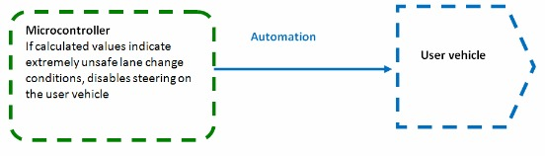

Hani Hadidi (HH), with the assistance of TM is responsible for this module. The first step to complete this module, which is to attain control over the car through the Arduino has been started. The Arduino is able to control the forward and backward speed of the user vehicle. Steering control is the next step. Once that is done, this module will need to be integrated with the input module to disable/enable steering under the circumstances listed in the lookup table.

The following is a list of key responsibilities for remaining of the term:

* Complete blind spot detection module (TM, VK)
  + Mount the sensor on the vehicle and optimize it’s placement to cover the blind spot region
  + Implement the look up table, and display feedback to the user with the LED
* Complete the Obstacle Anticipation Module (TM, VK)
  + Verify speed detection module when both the user vehicle and obstacle are in motion
  + Verify “time left” calculations, and display it on the LCD
* Complete the Automation module (HH, TM)
  + Achieve full control of the car through Arduino
  + Enable/Disable steering based on the look up table

Due to the heavy interaction between the input and output module, VK and TM worked together in many Instances. Also, TM has initially assisted HH with the Automation Module.

According to our initial Gantt Chart, the project is delayed. The group has designed a new Gantt chart to still ensure timely project completion. At the moment, no tasks have been cancelled. However, expected performance of design has been lowered due to unforeseen issues with the sensor.

**Appendix B: Project Goals and Requirements**

## Project Goal

The goal of the project is to aid in accident prevention through a device that will aid users identify and anticipate obstacles in their vehicle’s blind spot. In addition, the device will be able attain vehicle control to prevent the user from steering into obstacles in the blind spot. In order to achieve this, the group will build a prototype to be tested on scaled down vehicles (i.e. remote controlled cars) under simulated road conditions.

## Project Requirements

### Functional Requirements

1. The unit shall have sensors mounted on the sides (near the rear) of the user vehicle, such that it covers the defined blind spot region (Appendix F), and is able to obtain the distance to the obstacle and its position within the blind spot
2. The unit shall have a microcontroller to compute the following based on the inputs:
   1. The relative speed of the obstacle to the user vehicle within ±5% accuracy
   2. The amount of time needed for the approaching obstacle to appear in the blind spot, if not already there

3. The unit shall have a feedback mechanism to warn the user of potential danger based on the microcontroller's calculated relative speed and time allowed for a lane change (Appendix G, Appendix H)

4. The unit shall have an override mechanism that will prevent users from making unsafe lane changes by locking the steering of the user vehicle towards the obstacle under conditions outlined in Appendix H

5. The Unit shall adhere to the required technical parameters (Appendix E)

### Constraints

1. The unit must cost less than $500
2. The unit must weigh less than 1kg
3. The unit must not impede the user’s view of the road
4. The user vehicle must not exceed the maximum length of 12.5 m, and a maximum width of 2.6m (to be scaled down by the vehicle prototype ratio) with the unit attached [6]

### Objectives

1. The unit’s input sensor shall work correctly regardless of light and weather conditions
2. The blind spot detection component of the unit (no vehicle override) should be a standalone device
3. The microcontroller should be hidden from the user’s view